Name: _____________________________________________ Date: _____________________
Recognizing Cause and Effect in “To Build a Fire”
As we discussed in class, much of the literature of the Realist movement deals with events in the plot creating a cause and effect relationship. This is very true of “To Build a Fire”.
Ten-pin Alley
Use the text to identify one major event (bowling ball) that caused ten separate events to happen (bowling pins). This demonstrates cause-and-effect to be recognized and helps organize the many events in a story. Your “bowling ball” event does not have to come at the beginning of the story.
Bowling Ball: (page ______)
Quote the text here:

Pin 6: (page _____)
Quote the text:

Pin 1: (page _____)
Quote the text:

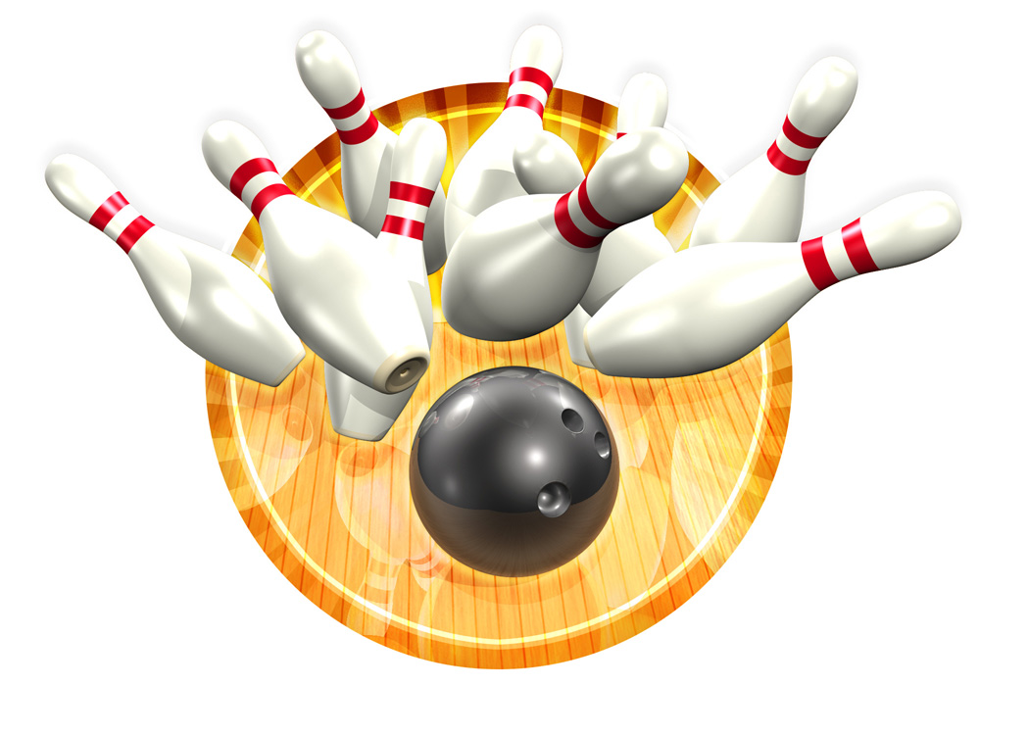
Pin 4: (page _____)
Quote the text:

Pin 3: (page _____)
Quote the text:

Pin 9: (page _____)
Quote the text:

Pin 8: (page _____)
Quote the text:

Pin 7: (page _____)
Quote the text:

Pin 2: (page _____)
Quote the text:

Pin 5: (page _____)
Quote the text:
Pin 10: (page _____)
Quote the text:

