11th grade American Literature
Spring 2018
Introduction to Transcendentalism

Below are 5 basic pillars of transcendentalism.

1. The inherent goodness of man:
“She warned him not to be deceived by appearances, for beauty can be found within.” ~Beauty and the Beast

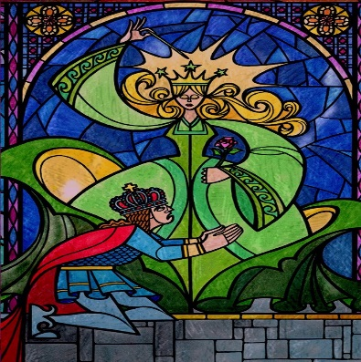
ADDITIONAL NOTES:

2. The importance of the individual:
“Your identity is your most valuable possession. Protect it.” ~The Incredibles

ADDITIONAL NOTES:

3. Self-Reliance:
“Promise me you’ll always remember: you’re braver than you believe, and stronger than you seem, and smarter than you think.” ~Christopher Robin to Winnie the Pooh

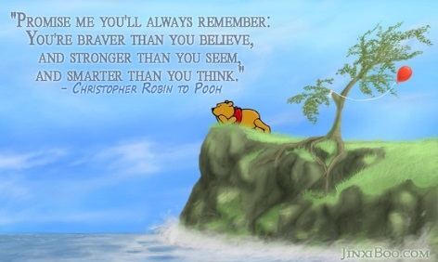
ADDITIONAL NOTES:

4. Belief in the “Oversoul”
“You don’t need human relationships to be happy. God has placed it all around us.”

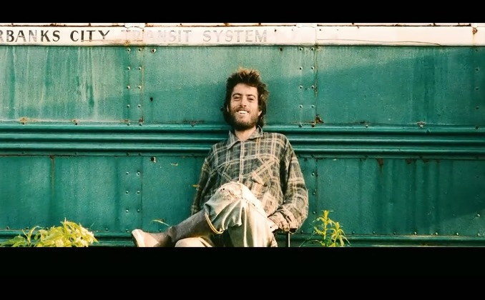

ADDITIONAL NOTES:

5. Non-Conformity:
“The flower that blooms in adversity is the most rare and beautiful of all.” ~Mulan
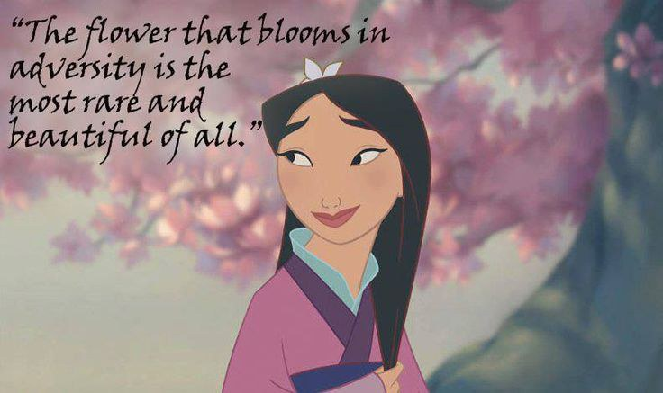
ADDITIONAL NOTES:

Part 2: Over the next day or so, we will observe examples of Transcendentalism in music and literature. Use this chart to summarize each piece and then list the specific elements of transcendentalism present.

Art/Music/Literature | Summary: In your own words paraphrase the main idea or overall theme of the work. 2-3 complete sentences | What elements of transcendentalism are present?
“The Lorax” by Doctor Seuss

“My Way” by Frank Sinatra

“Into the Wild” opening

“Into the Wild” film clip

